4

3

2

1

**The Siberian divisions were very important in the Soviet Union's victory against Nazi Germany during World War II. They helped in many ways:**

Siberian soldiers were known for being **tough**, fit, and brave because they lived in Siberia’s **harsh** climate. This made them great fighters who could **handle** difficult situations.

Siberian **troops** fought in big battles like defending Moscow, the Battle of Stalingrad, the Battle of Kursk, and freeing Europe. For example, more than twenty Siberian divisions and brigades helped defend Moscow by showing amazing strength and courage. In Stalingrad, Siberian soldiers also played an important part in defeating the Germans.

When parts of the battle front became weaker, Siberian divisions were sent there. Because they were disciplined and experienced, they could help make things better when other soldiers were tired from fighting. This allowed Soviet leaders to keep control and attack back.

After the war started, many new groups of soldiers were formed in Siberia and sent to the battlefield. These new units replaced soldiers lost early in the war and **strengthened** the Red Army.

In the end, Siberian divisions did a lot to win the war. They showed great skill, discipline, and love for their country.

**Find some information about Marshal of the Soviet Union G.K. Zhukov and tell your classmates about him.**

Activity

**throughout**-на протяжении

**tough**- стойкий, несгибаемый

**harsh**- суровый

**handle** -справляться

**troops**- войска

**tostrengthen**- усиливать

Vocabulary

***The Monument in Moscow to Siberian soldiers who defended the capital from the fascists***

**Match the headings (A-E) to the paragraphs (1-4). There is one extra heading.**

**A.**Strong Fighters

**B.** Strengthening Weak Areas

**C**. Helping at Home

**D**. Creating New Units

**E.** Key Battles

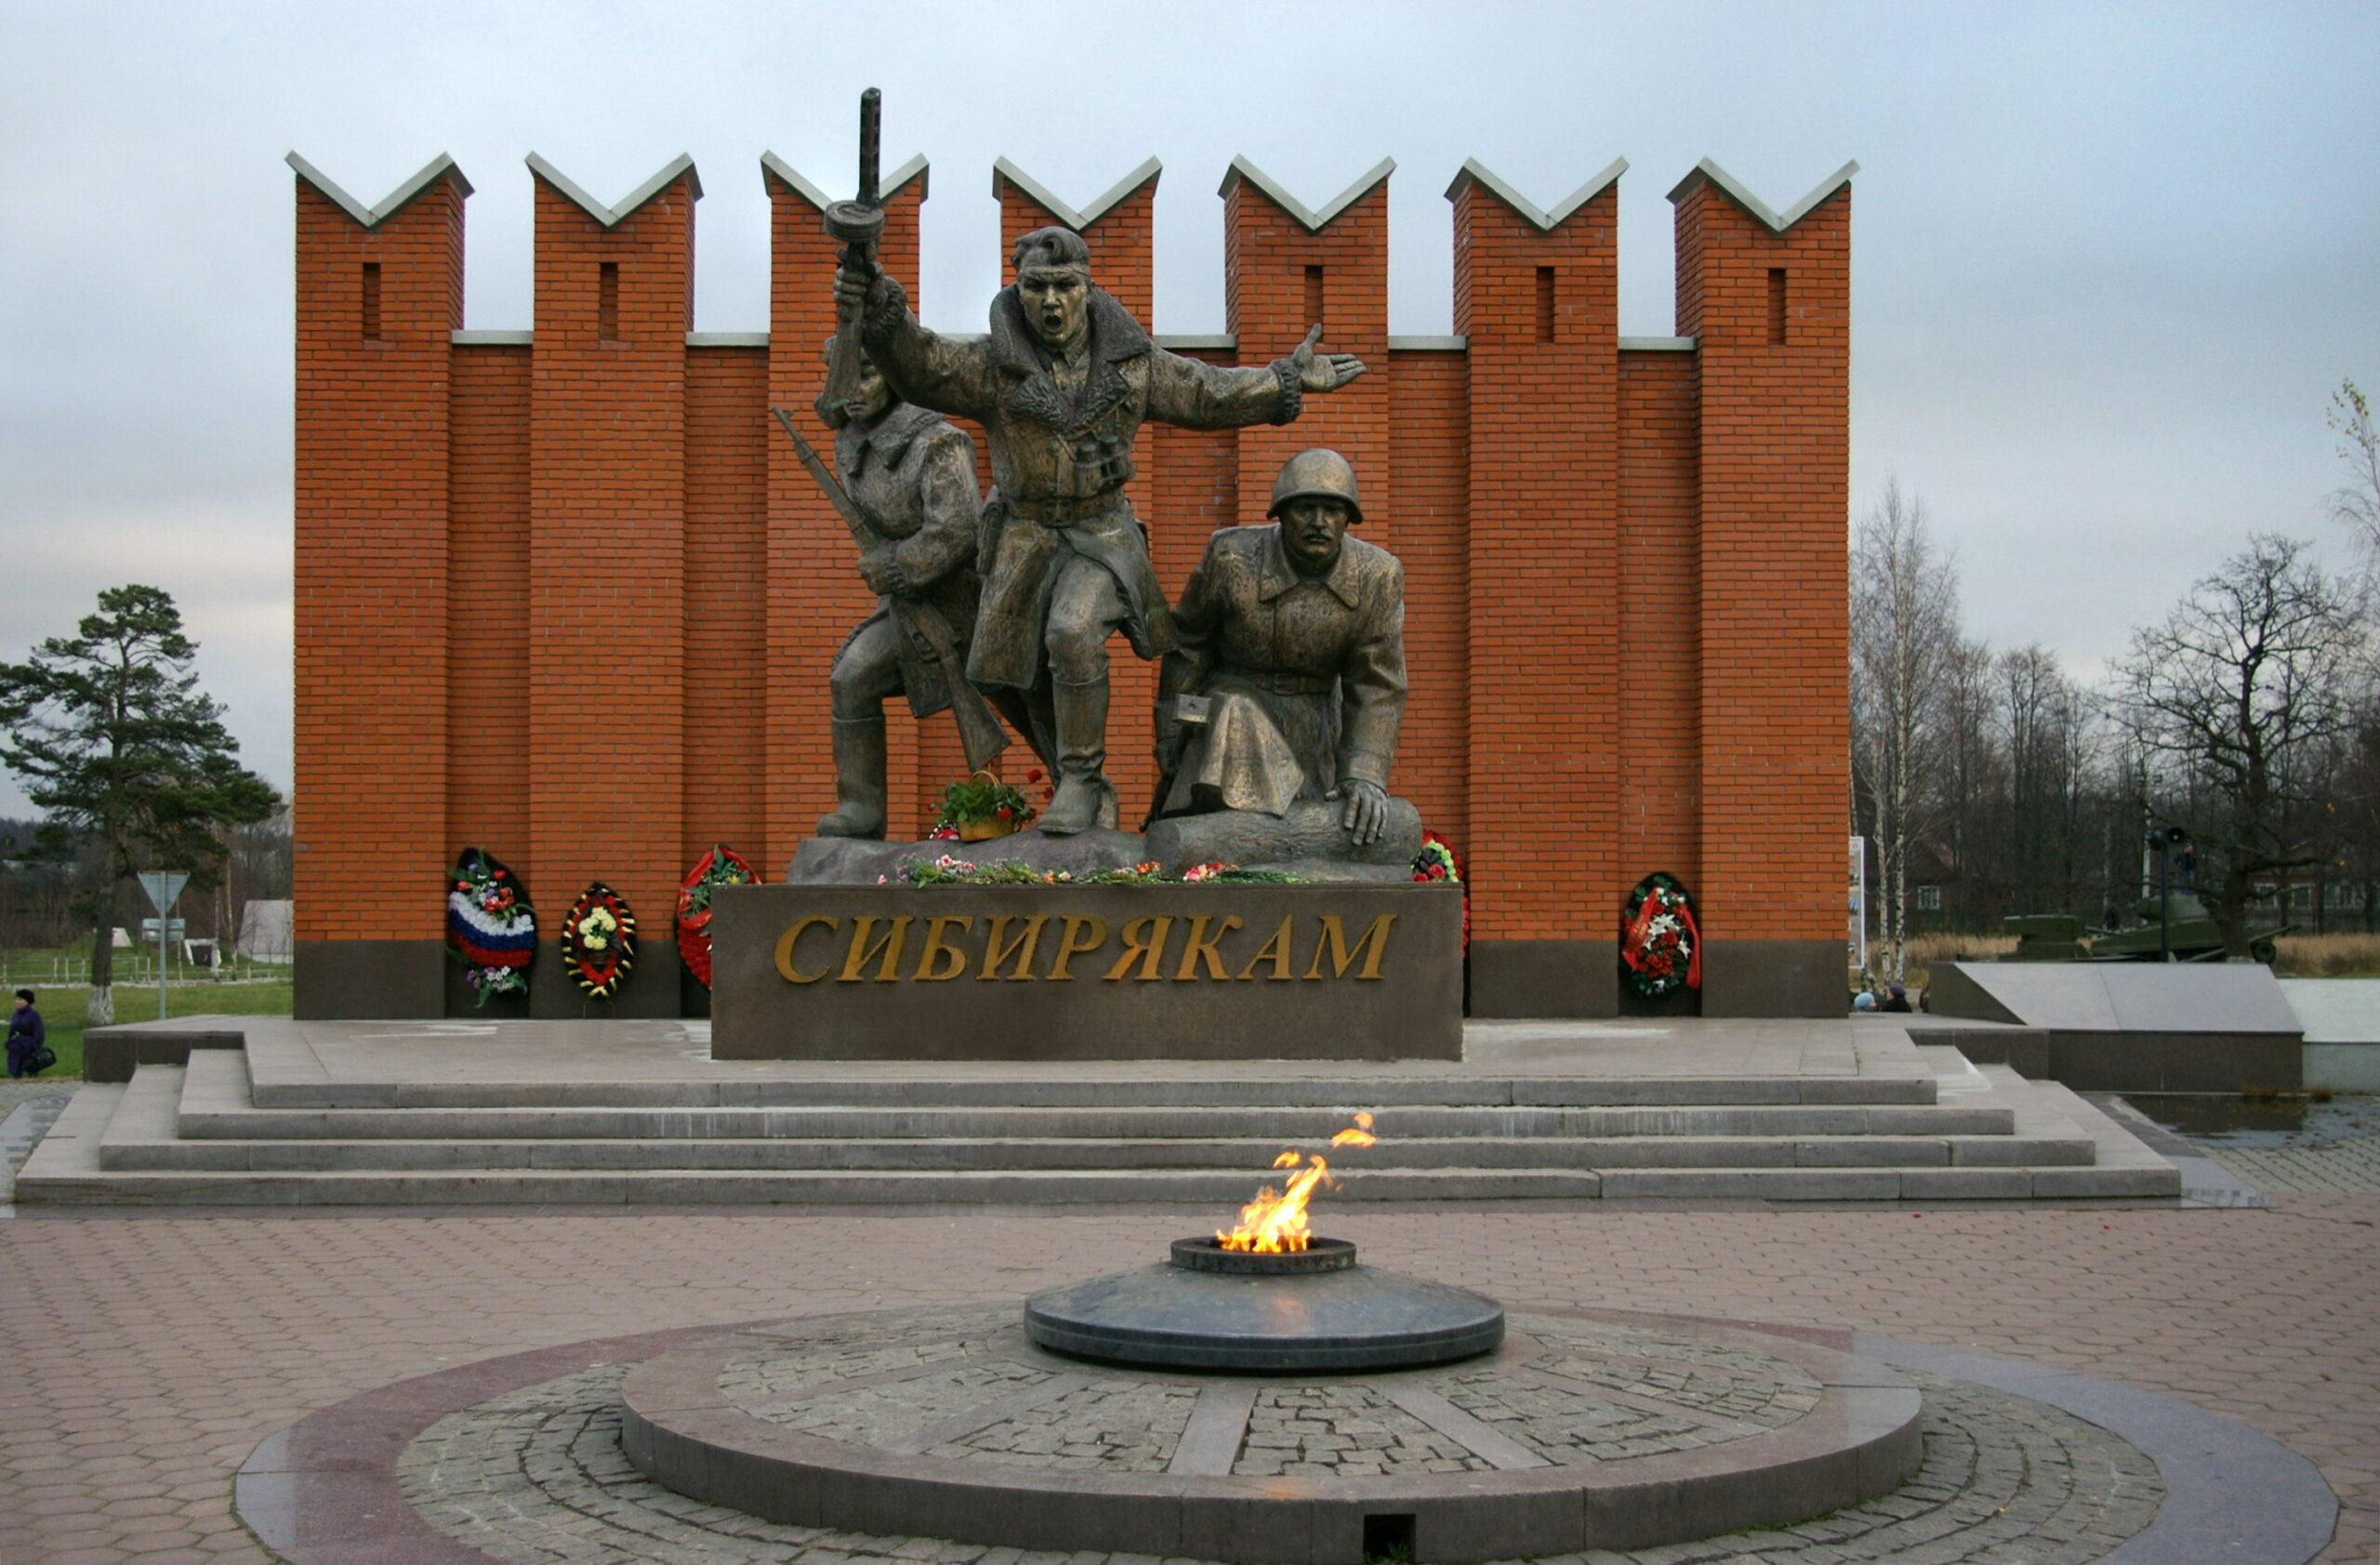

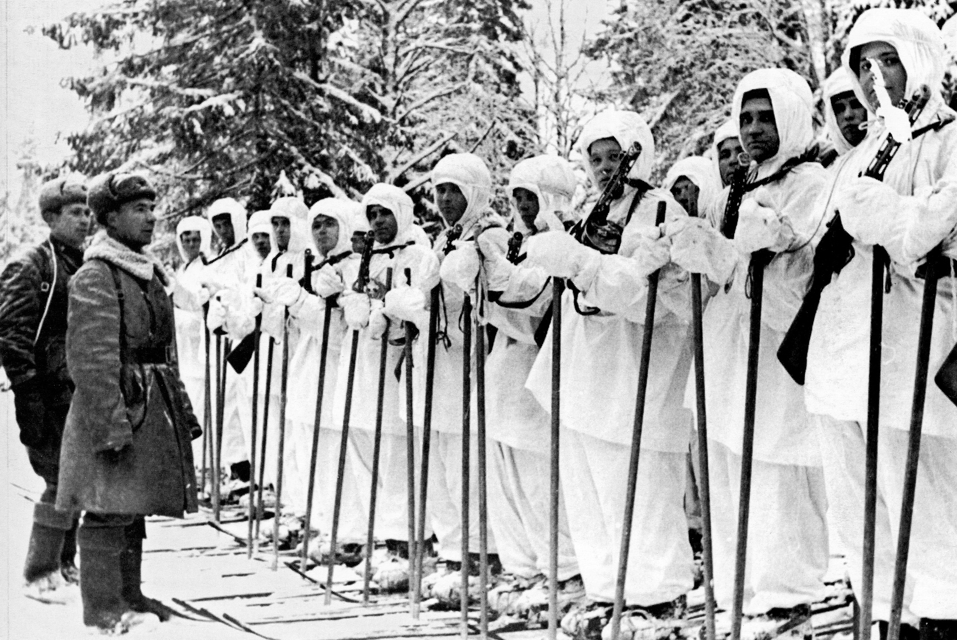



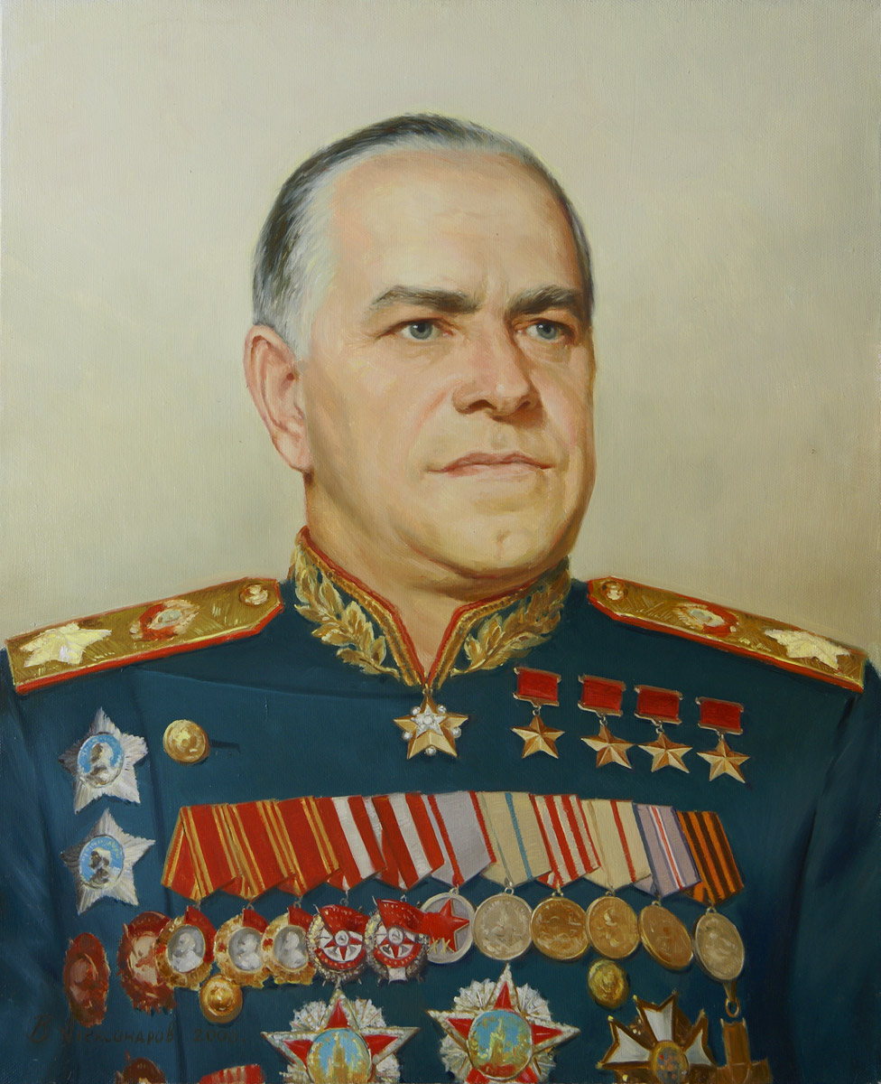

GeorgyKonstantinovich Zhukov,

Marshal of the Soviet Union

(1896-1974)

‘’Siberians are real heroes who truly love their country and always fight bravely for it. They always completed their missions with courage and honor. This was true **throughout** the whole war’’.

**Symbols of Victory.**

**Siberian Divisions.**